WIFLE SCHOLARSHIP PROGRAM 2024
February 1, 2024

BACKGROUND

WIFLE Foundation, Inc. and Women in Federal Law Enforcement, Inc. (known as WIFLE) are organizations that aim to achieve gender equity within federal law enforcement through the recruitment, retention, and promotion of qualified women.

According to the Department of Justice, Bureau of Justice Statistics, Federal Law Enforcement Officers 2020 statistics (released September 2022), about 15% of federal law enforcement officers and 13% of supervisory law enforcement personnel were female. Much remains to be done to achieve gender balance within the federal agencies. It is in the spirit of achieving this goal that WIFLE offers educational scholarships.

THE SCHOLARSHIP PROGRAM
Purpose:

WIFLE offers scholarships to talented individuals to meet demands in the field of law enforcement and to foster the professional development of those engaged in law enforcement. The dollar amount of each scholarship will be $2,500 but can vary based on numerous factors. The WIFLE Foundation awarded $15,500 in scholarships in 2023. Awards may be renewable on subsequent applications.

Eligibility

WIFLE scholarships are awarded based on a student’s academic potential, achievement, and commitment to serving communities in the field of law enforcement. The scholarship is open to all eligible persons. To qualify for the scholarship, the applicant must:

- Attend and be a full-time student at an accredited four-year college or university; or be currently enrolled in a full-time, fully accredited community college to transfer to a four-year degree;
- Have completed at least one full academic year of college work at an accredited college or university or community college;
- Major in Criminal Justice or a related discipline, such as social sciences, public administration, computer science, finance, linguistic arts, chemistry, physics, etc., leading to a four-year degree (Students in graduate and postgraduate programs are also eligible; students pursuing Associate degrees are not eligible, unless as stated above, fully articulate in the application their intention to transfer to a four-year program.);
- Have a minimum 3.0 overall grade point (GPA) average;
- Demonstrate a commitment to the community through a 500-word essay describing their involvement in a community project and the results or impact of that involvement on the community; OR, if the applicant is currently serving or has served an internship with a law enforcement agency, preferably a federal law enforcement agency, the applicant must provide details including the name of the agency, the dates served and describe the value of the experience and the accomplishment through the internship in a 500-word essay;
- Have at least one community leader or member of a community or police official sponsor their application with a written statement of support.
- Submit a completed application with the required information, a 500-word essay, transcripts, and a recommendation letter from a community leader or police official;
- Be a citizen of the United States.

SCHOLARSHIP APPLICATION PROCESS

Information and applications are available through the WIFLE website at https://wiflefoundation.org/scholarships/.

Submissions should include the scholarship application, college transcripts, essay, and sponsor letter(s). The Scholarship Coordinator must receive applications by May 1, 2024. Extensions will not be granted. Applications that are incomplete or received after the deadline will not be considered.

Recipients will be notified by May 20, 2024, and awards will be mailed directly to the educational institutions.

For answers to specific questions, contact WIFLE by email at WIFLE@comcast.net. Mail applications to:

WIFLE
Attention: Scholarship Coordinator
2200 Wilson Blvd.
Suite 102 PMB 204
Arlington, VA 22201

Or scan and email completed packages to WIFLE@comcast.net.

Sincerely,
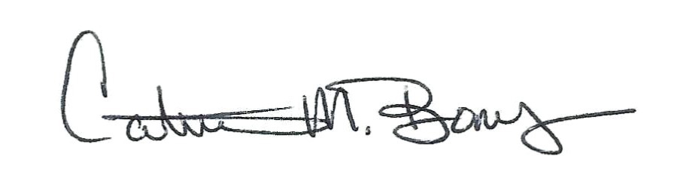

Catrina M. Bonus
President, WIFLE Foundation, Inc.
Executive Director, Women in Federal Law Enforcement, Inc.

WIFLE FOUNDATION, INC.
SCHOLARSHIP APPLICATION - 2024

Name: _________________________________________________________________________
Address: ________________________________________________________________________
_________________________________________________________________________
Work #: ________________________ Home #: _________________ Cell #: _______________________
E-Mail Address: _______________________________________________________________________
Current Occupation, if employed: __________________________________________________________
U.S. Citizen: Yes _____ No _____
Name of College or University attending: ____________________________________________________
Full-time Student: Yes ____ No ____ Physically Attending ______ On-line Program ________
Major: ________________________________________________________________________________

Total Credit completed to date: ______________ Grade Point Average (GPA): _____________________

Note: Provide College transcripts to substantiate GPA
Expected Date of Graduation: _____________________________
Name of Community Sponsor/Police Official/Law Enforcement Official, telephone number and email address:
_______________________________________________________________________________________

_______________________________________________________________________________________

Complete this application and submit it with your 500-word essay, college transcripts, and sponsor’s letter of recommendation. Forward all materials to:
WIFLE@comcast.net
or by mail to
WIFLE
Attention Scholarship Coordinator
2200 Wilson Blvd. Suite 102 PMB 204 Arlington, VA 22201

The application and all related materials must be received by May 1, 2024, to be considered.

