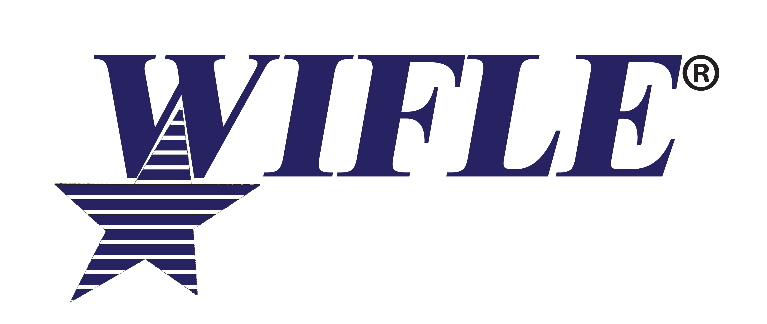  WIFLE 2021 Annual Awards Program  NOMINATION FORM:  The Elizebeth Smith Friedman  Intelligence Award of Excellence  WIFLE Intelligence Award | Criteria:  - Significant Act(s) may include one, several, or all of the below listed criteria.  - Demonstrated an exceptional and sustained level of intelligence analysis, which provided a substantial and broad impact in one or all areas of the field of intelligence as recognized by the agency and/or the intelligence community.  - Processed information into actionable intelligence in furtherance of a law enforcement operation, special event, such as National Special Security Event (NSSE), reduction/prevention of crime, and/or terrorism.  - Innovated intelligence integration functions to further investigative operations, secure/protect an event (NSSE), reduce/prevent crime, and/or prevent terrorism.  - Increased situational awareness, innovative intelligence techniques, and/or integrated views on issues of national security and public safety, in alignment to the ever-changing demands of the law enforcement profession or intelligence profession.  - Analyzed intelligence that resulted in significant contributions or enhanced the effectiveness of a complex investigative effort; the successful outcome of a special event(s) (NSSE); and/or law enforcement operation(s).  - Act took place between January 1, 2020, and December 31, 2020.  Eligibility: All full-time Federal law enforcement personnel, sworn and non-sworn and full time intelligence professionals from the Intelligence Field. An individual or group may be nominated. Nominee must be full time employee by February 1, 2021

NOMINEE INFORMATION
Name: ________________________________________________________________

Agency: ________________________________________________________________

Address: ________________________________________________________________

Business Telephone: ______________________ E-Mail: __________________________

Position: __________________________________________________________________

Years of Government Service: ____________

AGENCY INFORMATION

Signature of Nominating Official: ______________________________________________

Title of Nominating Official: __________________________________________________

Nominating Agency: ________________________________________________________

Name of Agency Official to be notified of final award selections:

Name: ______________________________ Telephone: ____________________________

E-Mail: ___________________________________________________________
IMPORTANT: Deadline for Nominations is May 3, 2021.

Narrative justification must be no longer than three typed written pages. Attach narrative justification to this cover sheet and submit to wifle@comcast.net or via mail at WIFLE, 2200 Wilson Blvd., Suite 102, PMB 204, Arlington, VA 22201.

Please Note: Each agency may submit only 3 nominees per award.
WIFLE 2021 Annual Awards Program  NOMINATION FORM:  TOP PROSECUTOR AWARD | Criteria:  - Demonstrates exceptional work in obtaining a conviction for individual(s) engaged in the following crimes: trafficking of women or children for sexual exploitation or any individual for forced labor; committed or attempted to commit a crime of violence against women or any minority group; committed a civil rights violation; committed any terrorist-related violation against the United States; or, committed any corporate or governmental fraud.  - Prosecution must have occurred between January 1, 2020 and December 31, 2020.  Eligibility:  -All full-time Federal prosecutors. An individual or a group may be nominated.  -All nominees must be full-time government employees as of February 1, 2021.

NOMINEE INFORMATION

Name: _____________________________________________________

Agency: _____________________________________________________

Address: _____________________________________________________

Business Telephone: ______________________ E-Mail: ________________

Position: ________________________________________________________

Years of Government Service: ____________
AGENCY INFORMATION

Signature of Nominating Official: ____________________________________

Title of Nominating Official: ________________________________________

Nominating Agency: _______________________________________________

Name of Agency Official to be notified of final award selections:

Name: Telephone: ___________________________________

E-Mail: __________________________________________________________________________

IMPORTANT: Deadline for Nominations is May 3, 2021.

Narrative justification must be no longer than three typed written pages. Attach narrative justification to this cover sheet and submit to wifle@comcast.net or via mail at WIFLE, 2200 Wilson Blvd., Suite 102, PMB 204 Arlington, VA 22201.

Please Note: Each judicial district or DOJ Main Office may submit 3 nominees per award.
WIFLE 2021 Annual Awards Program  NOMINATION FORM:  WIFLE PARTNERSHIP AWARD - OUTSTANDING CONTRIBUTION OF A STATE OR LOCAL OFFICER SERVING ON A FEDERAL  TASK FORCE | Criteria:  - Demonstrates exceptional investigative work in a task force group or in a task force environment investigating individual(s) or group engaged in the following crimes: trafficking of women or children for sexual exploitation or forced labor; crime(s) of violence against women or any minority group; civil rights violation(s); any terrorist-related violation against the United States; or, any corporate or governmental fraud.  - State or local officer serves as a vital member of the team, demonstrates exemplary conduct and willingness to advance the objectives of the task force and recognized by the supervision/management of the department and the federal agency for those attributes.  - Individual nominated serves as a role model for women in law enforcement.  - Investigation must have concluded or been adjudicated between January 1, 2020 and December 31, 2020.  Eligibility:  -All full-time sworn State or Local Law Enforcement Officers.  -All nominees must be full-time employee with their agency/department as of February 1, 2021.

NOMINEE INFORMATION

Name: ________________________________ Position: _____________________________________

Agency: _______________________________Name of Task Force: _____________________________

Address: ______________________________________________________________________________

Telephone: ____________________ E-Mail: ______________________Years of Service: ____________

AGENCY INFORMATION

Signature of Federal Agency Nominating Official: ______________________________________________

Title of Nominating Official: ____________________________Nominating Agency: __________________

State or Local Commanding Officer: ________________________________________________

Signature: ______________________________________________________________________

Title of Commanding Officer: ______________________________________________________________

Name of Agency Official to be notified of final award selections:

Name: ______________________________Telephone: ________________E-Mail: ___________________

IMPORTANT: Deadline for Nominations is May 3, 2021.

Narrative justification must be no longer than three typed written pages. Attach narrative justification to this cover sheet and submit to wifle@comcast.net or via mail at WIFLE, 2200 Wilson Blvd., Suite 102, PMB 204 Arlington, VA 22201.

Please Note: Each judicial district or Federal Law Enforcement Agency may submit 3 nominees per award.

