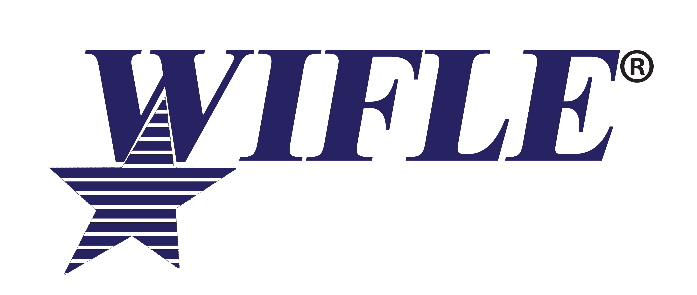
February 1, 2021

Dear United States Attorney:

Women in Federal Law Enforcement, (WIFLE) an organization working to promote the value that women bring to law enforcement, will hold its annual leadership training August 16-19, 2021, at the Marriott Water Street, Tampa, Florida. A special leadership-training day will be held on August 16th for early arrivals. This year’s training program will focus on leadership skills necessary for advancement in the ranks of government, as well as examine key law enforcement, security, and intelligence issues. Our speakers will address issues of civil rights, intelligence gathering and dissemination, protecting the technology infrastructure, leadership issues, combating terrorism, human trafficking, and working closely with state/local counterparts in enforcement efforts.

This year due to COVID-19, we anticipate that states will require WIFLE to collect individual information from each attendee as to whether they have received a coronavirus vaccine. Therefore, we will be requesting this information from each registrant at the time they register.

During our week of leadership training one of our highlights is the presentation of awards to recognize individuals and groups from the federal agencies for the excellent work they perform. The awards Banquet will take place on Wednesday, August 5th at 7 pm. Awards are presented for valor with the Julie Y. Cross Award, The Elizebeth Smith Friedman Intelligence Award for Excellence, the Outstanding Advocate for Women in Federal Law Enforcement, the Outstanding Federal Law Enforcement Employee, the Top Prosecutor Award, the WIFLE Leadership Award and the WIFLE Partnership Award recognizing the contributions of a state or local officer assigned to a federal task force or working in a task force environment. Each awardee and their guests along with their agency head or representative are invited to our VIP reception beginning at 6:00 pm. This will allow agency executives to meet their awardee’s family and guests.

Early registration is $525.00 and will close on June 30, 2021. Please visit the Foundation website at wiflefoundation.org www.WIFLE.org for details. Hotel rates will be equivalent to the government rate of $124.00 per night and can also be accomplished online. Enclosed are nomination forms for Top Prosecutor, the Elizabeth Smith Friedman Intelligence Award, and the WIFLE Partnership Award for Outstanding Contribution of a State or Local Officer Serving on a Federal Task Force. Any questions please call WIFLE at 301-805-2180 or email wifle2021@wifle.org.

I would also like to invite you to our Opening Ceremony on Tuesday, August 17, 2021, at 8:00 am. We look forward to meeting you and your agency’s personnel.

Sincerely,
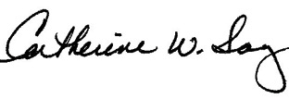
Catherine W. Sanz
President
WIFLE Foundation, Inc.

