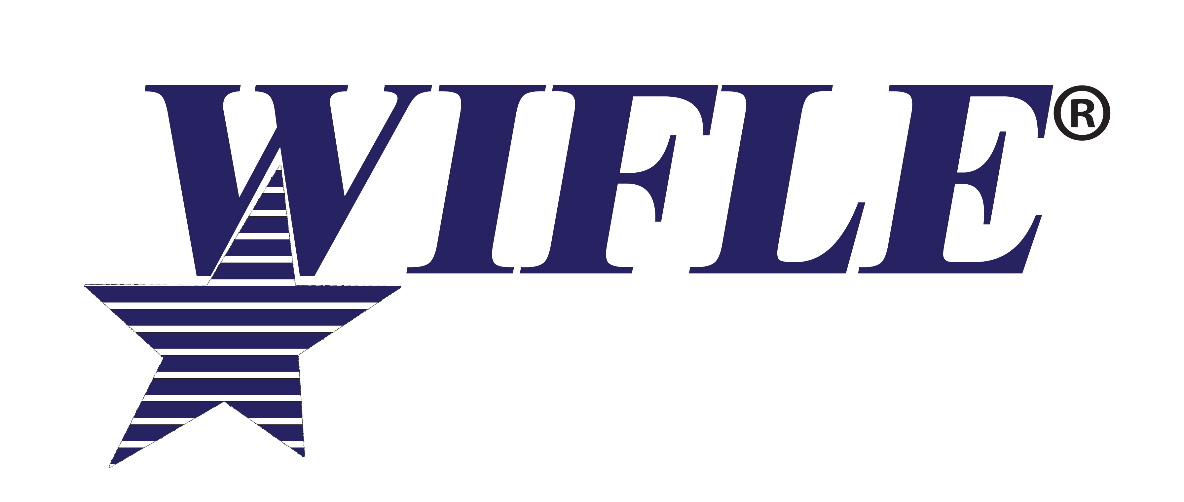
February 1, 2020

Dear United States Attorney:

Women in Federal Law Enforcement, (WIFLE) an organization working to promote the value that women bring to law enforcement, will hold its annual leadership training August 3-6, 2020, at the Marriott Water Street, Tampa, Florida. A special leadership-training day will be held on August 3rd for early arrivals. This year’s training program will focus on leadership skills necessary for advancement in the ranks of government, as well as examine key law enforcement, security and intelligence issues. Our speakers will address issues of civil rights, constitutional policing, intelligence gathering and dissemination, protecting the technology infrastructure, leadership issues, combating terrorism, human trafficking, working closely with state/local counterparts in enforcement efforts, and close with looking at “you and your federal career.”

During our week of leadership training one of our highlights is the presentation of awards to recognize individuals and groups from the federal agencies for the excellent work they perform. The awards Banquet will take place on Wednesday, August 5th at 7 pm. Awards are presented for valor with the Julie Y. Cross Award, The Elizebeth Smith Friedman Intelligence Award for Excellence, the Outstanding Advocate for Women in Federal Law Enforcement, the Outstanding Federal Law Enforcement Employee, the Top Prosecutor Award, the WIFLE Leadership Award and the WIFLE Partnership Award recognizing the contributions of a state or local officer assigned to a federal task force or working in a task force environment. Each awardee and their guests along with their agency head or representative are invited to our VIP reception beginning at 6:00 pm. This will allow agency executives to meet their awardee’s family and guests as well as take pictures.

Early registration is $525.00 and will close on May 31, 2020. Please visit our web site at www.WIFLE.org for details. Hotel rates will be equivalent to the government rate of $122.00 per night and can also be accomplished online. Enclosed are nomination forms for Top Prosecutor and the Elizabeth Smith Friedman Intelligence Award. Any questions please call WIFLE at
301-805-2180 or email wifle2020@wifle.org.

I would also like to invite you to our Opening Ceremony on Tuesday, August 4, 2020, at 8:00 am.
We look forward to meeting you and your agency’s personnel.

Sincerely,
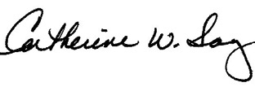
Catherine W. Sanz
President
WIFLE Foundation, Inc.

